
***FOR IMMEDIATE RELEASE***

CRAZY RICHARD’S EXPANDS CLEAN NUT BUTTER LINE WITH TWO EXCITING NEW LAUNCHES: NATURAL NO-STIR PEANUT BUTTER AND CINNAMON ALMOND BUTTER
—The trusted brand in better-for-you spreads makes clean eating even easier and more flavorful—

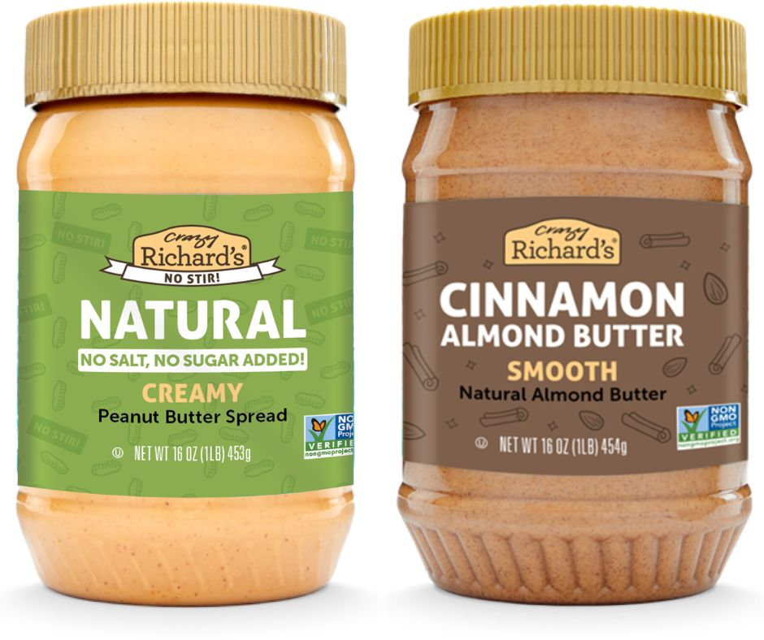

Columbus, OH – May 1, 2025 — Crazy Richard’s, the brand known for its no-nonsense, clean-label nut butters, is proud to introduce two delicious new additions to its product lineup: Natural No-Stir Peanut Butter and Cinnamon Almond Butter. These innovations bring both simplicity and flavor to the forefront, helping customers stay on track with their better-for-you journey — every step of the way.
Natural No-Stir Peanut Butter offers the same beloved Crazy Richard’s roasted peanut taste — now with the convenience of a stir-free consistency. Made with just two ingredients — U.S. peanuts and a touch of sustainably sourced palm oil — this new spread delivers a creamy, mess-free experience with no added sugar, salt, or hydrogenated oils.
“We heard from so many customers who love our classic peanut butter but needed an option that was more convenient to use — especially for busy mornings or those with limited mobility,” said Kimberly Wernli, President and Owner of Crazy Richard’s. “Natural No-Stir is our answer to that, without compromising the clean integrity of our ingredients.”
Joining the lineup alongside the No-Stir Peanut Butter is Cinnamon Almond Butter, a craveable blend of California almonds, real cinnamon, a touch of organic cane sugar, and sea salt. It brings a warm, gently sweet flavor to the table — a fun and flavorful twist that still stays true to Crazy Richard’s commitment to simple, recognizable ingredients.
“Cinnamon Almond Butter was born out of real feedback from our community,” Wernli added. “People asked for a flavor-forward option that fits their clean-eating goals — and this one’s quickly become a new fan favorite.”
Both new products — Natural No-Stir Peanut Butter and Cinnamon Almond Butter — are available now on Amazon and on shelves at all Harris Teeter stores, with distribution arriving soon at Giant Eagle, Hy-Vee, Wies, Marc’s and all Kroger banner stores nationwide.
Crazy Richard’s continues to lead the clean nut butter category with its transparent ingredient lists, sustainability-minded practices, and consumer-driven product innovation — all while supporting families on their better-for-you path.
For more information, visit www.crazyrichards.com or follow @crazyrichardspb on Instagram

###

